is speaking
in the pond

The tiger

is skipping
with the panda.
The hippo


is dancing
with an elephant.
The snake

is sleeping
under a tree.
The giraffe

with the kangaroo.
The monkey
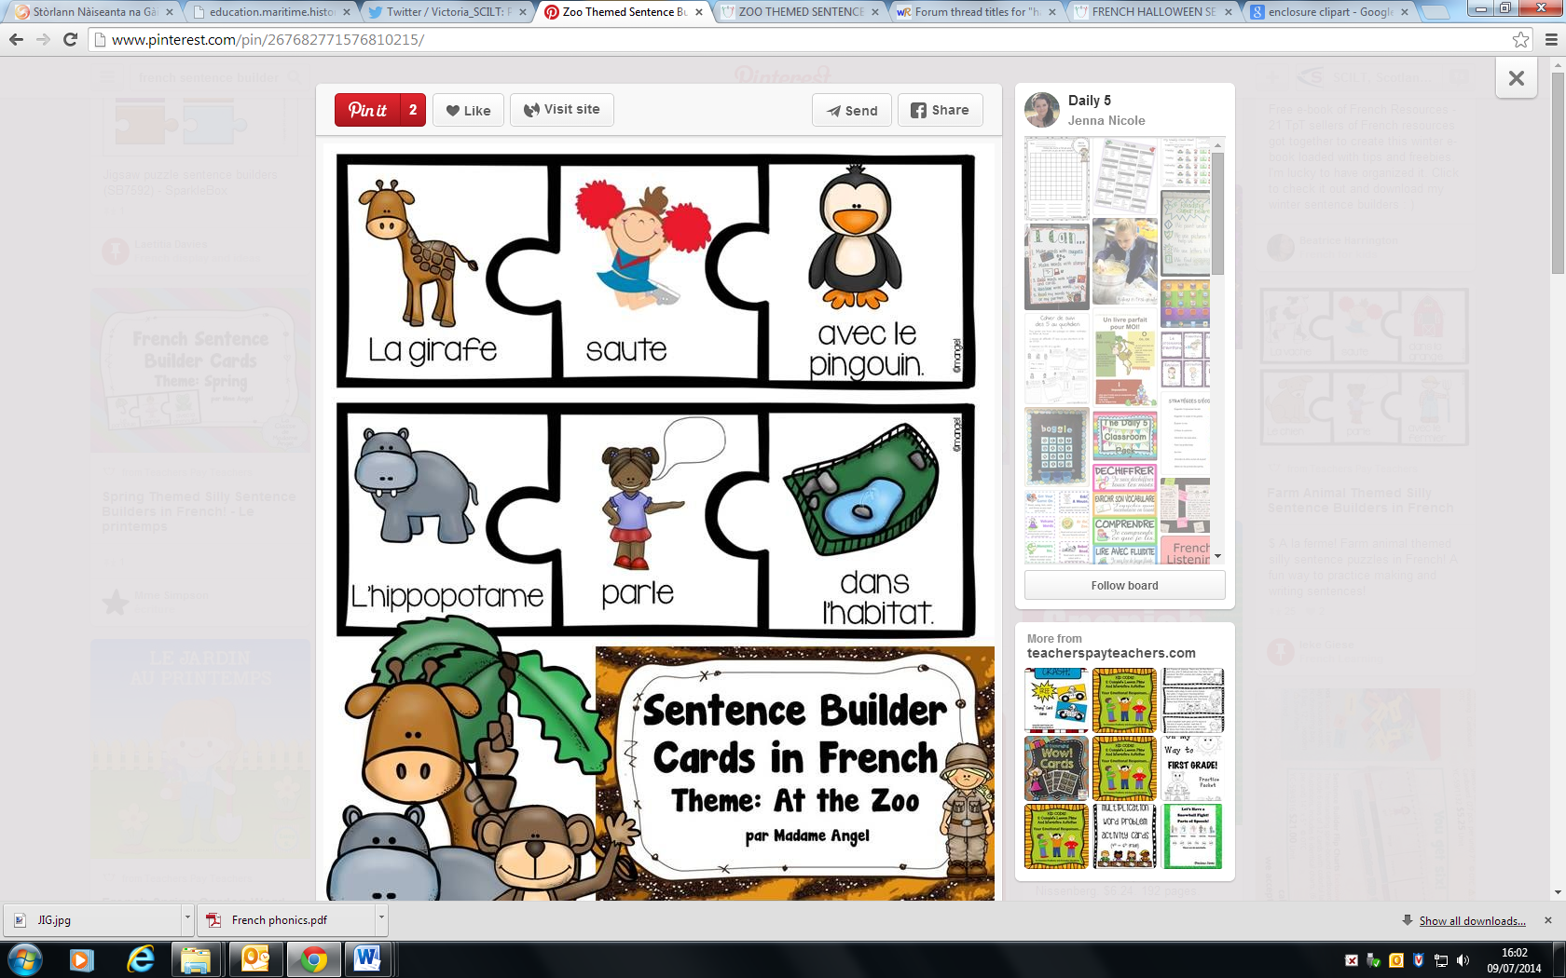
in the habitat.
is singing
is swimming
The zookeeper

for the children.
is playing the guitar
The peacock
is eating pizza
with the bears.
The penguin

